Media and information, much like almost anything in the world, is a dynamic and developing entity. It is ever-changing in nature – a product of continuous improvement. The photos above are just a few examples of the many technologies and innovations that have emerged throughout the recent years. Here, you will explore more of these developments and visualize what the future may bring in terms of the trends in media and information.

### 1. Massive Open Online Courses

EDUCAUSE, a nonprofit organization composed of IT leaders and professionals, defines MOOC as “a model for delivering learning content online to any person who wants to take a course, with no limit on attendance.”

Furthermore, MOOCs can be characterized by the following:

1. A revolutionary approach to education that transitions from physical setting to a virtual set-up
2. A kind of learning that is facilitated online, breaking the norm of having to physically go to traditional schools or universities for higher education
3. Utilizes information technologies like analytics to help instructors evaluate their students’ learning
4. Emphasizes connectedness (Gonzales, 2016)

MOOCS are asynchronous, open-access, Web-based courses geared toward enrolling hundreds or thousands of students at a time. MOOCs deliver content via recorded video lectures, online readings, and online assessments, as well as various degrees of studentstudent and student-instructor interaction (Kurt, 2018). People enroll in MOOCs for a range of purposes, including Career development, college preparations, supplemental learning, lifelong learning, corporate training, and more.

There is a distinction though as to whether an online learning material or program is considered as a MOOC. Here are a number of features that are typically required for a course to be considered a MOOC:

1. **Massive** - It should allow access to a very large number of students, much larger than a face-to-face class, or a traditional online course. It can even reach up to 500,000 learners or more!
2. **Open** – It does not have an admission process nor qualifications to be able to register or enroll. MOOCs being open also means free and open access to educational resources hosted in varied online places.
3. **Online** – The course is done remotely via the Internet and does not require physical attendance at a classroom, which also means that anyone from anywhere around the world with an Internet connection can avail of these courses.
4. **Courses** - It should have learning objectives to be achieved by students after certain activities within a given period of time.

MOOCs are made and hosted by universities and companies through open enrollment or open registration. However, most of these institutions do not host MOOCs under their organization per se but rely on course providers such as Coursera, edX, Udacity, and many others. They range in length from 1 to 16 weeks (Bowden, 2019). While others run on a schedule, MOOCs remain flexible, letting you progress through them at your own pace, which means you are able to go through the lessons and activities according to your schedule.

Like in a traditional classroom, students will also be graded through quizzes, assignments, or activities. However, these may come as peer review graded by other students according to a rubric or automatically-marked tests which are graded directly upon submission.

MOOCs offer a strong starting point for a number of reasons, including:

1. **Lack of entry requirements** – a MOOC can be taken by anyone who is interested in the subject matter and able to access the course, regardless of age, background, or location
2. **Repetition** – a MOOC will often run two or three times a year, ensuring that students won’t miss their chance
3. **High** **quality** – MOOCs are led by subject matter experts (SMEs) and supported by teaching assistants so that students have access to first-rate educational resources
4. **Feasibility** – a MOOC usually necessitates around 1-2 hours of study a week for about five weeks, making learning doable for students with busy lives
5. **Self-paced but supported learning** – a MOOC enables students to work through the course materials and assessments at their own rates while also interacting with a global learning community (Kurt, 2018).

In sum, MOOCs are a game-changer for higher education. The large scale availability, the low cost to students, the questions raised around credentialing, and the analytics that MOOCs provide all create momentum for new pathways to education.

### 2. Wearable Technology

Also known as **wearables** or **fashion technology**, wearable technology is a general term that encompasses a field of smart devices that are worn on the body. This technology is also considered as a trend in media and information as with it, people and access information through media in a much faster manner.

Earlier versions of wearables were devices clipped to the body or on pieces of clothing. Today, however, advancements in technology allowed powerful sensors to have direct contact with the skin. Thus, the tech gravitated to other body parts: the wrists, fingers, chest, forearms, ears, eyes, forehead, temple, and anywhere else you can think of.

According to Wearable Devices magazine (Liquigan, 2016), the characteristics of wearable include the following:

* Performing computer-related tasks such as laptops and mobile phones
* Provide sensory and scanning features
* Have some form of communication capability and will allow the wearer access to information in real-time
* Data-input capabilities
* Local storage capabilities

Wearable technology is growing to be one of the fastest-rising innovation in the ICT industry. The new age of wearables is loaded with smart sensors that track our movements and biometrics, often using Bluetooth to sync wirelessly to a smartphone. Others also rely on Wi-Fi connectivity and standalone mobile 4G LTE data connections. Wearables also use sensors to connect to you as a person, helping you to achieve goals such as staying fit and active, losing weight, being more organized, or tracking your overall mental and physical health. In the case of VR and AR heads-up displays, they’re providing a wealth of new entertainment and educational opportunities, as well as enhancing the world around us

(Smith, 2019).

Different fields, such as in gaming, music, entertainment, health and medicine, fitness and wellness, education, transportation, and many others, have slowly started to adapt to the use of this technology. Let’s look at these examples of wearable tech:

### 1. Smartwatch

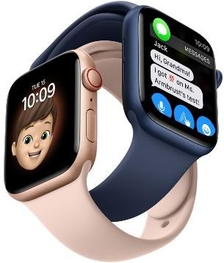Smartwatches are wrist-worn devices that connect to your mobile phone. As they are synced to your smartphone, it allows you to see notifications on your wrist at a glance. This technology eases the burden of having to constantly open and check your smartphone text messages, e-mails, or other notifications. It can even track your physical activity! Most smartwatches rely on a smartphone to function, which also means the model you choose will depend on your phone.

For example, the **Apple Watch** can only be synced with an iPhone, while Android Wear devices—such as the **Moto 360** and **Samsung Gear**—can only be connected to Android phones.

Image Source: **“Apple extends the Apple Watch experience to the entire family”** https://www.apple.com/newsroom/2020/09/apple-extends-the-apple-watch-experience-to-the-entire-family/

### 2. Fitness trackers and sports watches

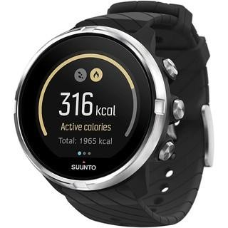

Whether for formal training or just trying to be active and fit, fitness trackers and sportswatch help you get a better understanding of your fitness activities. According to GCF Global, they can track the **number of steps you take**, **your average heart rate**, **how long you sleep**, and more. This data can then be synced with another device, which allows you to see trends and patterns in your activity. For example, you could find out how far you’ve walked over the past week or estimate how many calories you’ve burned in a day. *Image Source:* ***“Suunto 9, GPS Sports Watch”***

### 3. Smartglasses

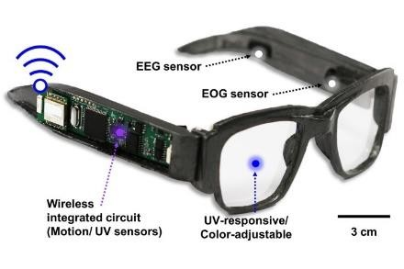

*Image Source:* ***“Smart Glasses”*** https://newatlas.com/tag/smartglasses/https://shopee.ph/Suunto-9-GPS-Sports-Watch-with-Long-BatteryLife-and-Wrist-Based-Heart-Rate-i.153460743.3436281795

No longer do your specs just help you see things more clearly: smart glasses can link up with your phone, control the volume of your music, and even take photographs (Stevens, 2018). Google Glass was the first to launch this technology in 2013. Basically, it brings wireless connectivity and imaging into the frames and lenses of our eyewear, controls that we can only usually do on our smartphones and computers. So instead of a keyboard or mouse, you can control smart glasses by tapping or swiping control built into the frame or even verbalizing your commands as you do with Alexa and Siri.

### 4. Hearables

Most have had or known earphones and headphones throughout their lives. Today, these devices, like the ones we previously discussed, have now also utilized wireless connectivity as well. These Hearables work just like the traditional earphones and headphones but are already wireless and are worn in the ear. The most popular example is Apple’s AirPods, those true wireless earphones that offer quick access to the Siri voice assistant. However, these hearable aren’t only for music or entertainment, but some are actually used as smart hearing aids.

*Image Source:* ***“Apple AirPods”*** https://www.amazon.com/Apple-AirPods-Charging-Latest-

Model/dp/B07PXGQC1Q

### 5. VR Headsets

*Image Source:* ***“10 Uses and***

***Benefits of Virtual Reality in Tourism”*** https://www.businessworldit.com /ar-vr-technologies/10-uses-andbenefits-of-virtual-reality-intourism/

### 3. 3D Environment

VR or Virtual Reality headsets are devices connected to a PC/games console and show you a computer-generated virtual reality that fools you sight and your brain into thinking you are in a different scenario.

Today, many industries and fields are using and developing more innovations of these wearable techs, especially in the health care industry, where they’re looking into devices that could be used to monitor things like blood pressure, vital signs, or blood sugar levels for diabetics. From the basic fitness trackers and highly-advanced sports and smartwatches to virtual and augmented reality headsets, wearables are definitely establishing their names. As such, wearable technology will most likely continue to have an impact on modern society, especially given its efficient use and aesthetic quality.

3D or three-dimensional, in its literal sense, refers to anything that has a width, height, and depth (Gonzales, 2016). The physical world, the realm we live in, including us humans, are examples of 3D environments. This technological concept of a 3D environment is explored to imitate and simulate the physical world through media. The most common examples of this are computer animations in video games and TV shows. Films have also been among the most common media modalities that employ 3D. 3D films make objects in their material appear solid to the audience through the illusion of perception (Gonzales, 2016). If you have been to one of these 3D films, you are made to wear special 3D glasses, which directs each of your eyes to see a slightly different picture. According to American Paper Optics, a manufacturer of 3D eyewear, “this is done in the real world by your eyes being spaced apart, so each eye has its own slightly different view. The brain then puts the

two pictures together to form one 3D image that has depth to it.

Another 3D technology, which has existed for actually quite a while now, is **3D printing**. This innovation brings digital data and design to the physical world – literally. Simply put, it brings your design to life! According to The University of Tennessee Knoxville, 3D printing “creates objects by bonding the print material one layer at a time. They work by making use of 3D design files, such as those created in AutoCAD, Google SketchUp, or similar applications. These files are processed by specialized software that slices the data into cross-sections. The printer uses this data to build the desired object from the bottom up one layer at a time.” Unlike laser printers that utilize inks, 3D printers “prints” in layers of material like plastic, metal, and concrete.

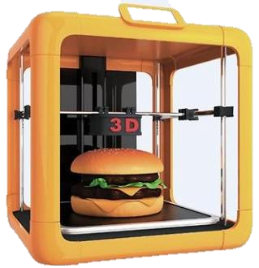

*Image Source:* ***“3D Printing”*** https://www.blendspace.com/lesso ns/bkvmF5s1Dtg3KA/3d-printing

Overall, the 3D environment has already been widely used because it gives the audience a more engaging and enjoyable media experience because the images and videos are in three-dimensional rendering – meaning it’s as if we’re looking at something real!

### 4. Ubiquitous Learning

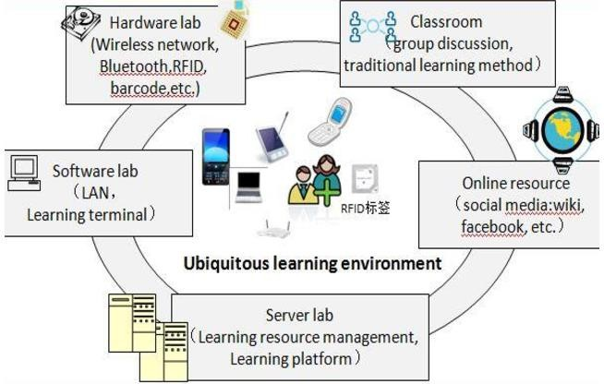 Ubiquitous learning or **“u-learning**” is a kind of e-learning experience that “implies a vision of learning which is connected across all the stages on which we play out our lives. Learning occurs not just in classrooms, but in the home, the workplace, the playground, the library, museum, and nature center, and in our daily interactions with others (Bruce, 2009).” Compared to mobile learning and elearning, it is a more context-based approach and more adaptive to the needs and pacing of the learner.

*Image Source:* ***“The Benefits and Potential of Innovative Ubiquitous Learning Environments to Enhance Higher Education Infrastructure and Student Experiences in Saudi Arabia”*** https://scialert.net/fulltext/?doi=jas.2010.2358.2368

.

U-learning is a kind of wireless modality where learning takes place at any time, anywhere, and with anyone. It benefits from the use of technologies to implement learning activities and achieve learning objectives. These technologies incorporate learning materials such as videos, audios, PowerPoint presentations, or notes with embedded source data in them (Liquigan,

2016). It is a very personalized and dynamic mechanism that uses devices integrated into the students’ environment. Furthermore, u-learning maximizes the use of any form of media like mobile phones and computers for efficient use.

However, in the Philippine setting, especially in the public education system, most u- learning tools fail to endure because of the lack of resources and, thus, not effectively sustaining the actual needs of the students. It is, nevertheless, still a promising endeavor that both private and public education institutions hope to embark on.

### 5. Paperless Society

A call for faster transactions and greener mechanisms brought paperless transactions as a viable and useful practice in society. A **paperless society** is a society where communication and transactions are done electronically or digitally, and all forms of printed communication have become obsolete. It is characterized by the shift from letters to e-mails, newspapers to news web pages, books to e-books, and so on (Gonzales, 2016). Paperless transactions also include cashless dealing, which is often done through credit or debit cards or through virtual wallets like PayMaya and GCash.

*Image Source:* ***“Wolverton: Paperless society remains a distant dream”*** https://www.mercurynews.com/2015/04/17/wolverton-paperless-society-remains-a-distant-dream/

Going paperless offers several benefits, like acquiring savings on costs on materials, printing, labor, and storage. In addition, paperless transactions minimize the risk of losing or misplacing a digital document and allow employees to access and edit a digital document, whether remotely or in the office, then electronically manage or send it. These documents can also be accessed simultaneously, eliminating the need for multiple copies and thus saving time and adding to work efficiency.

However, for a country like the Philippines where many places are still without electricity, even more so Internet, going entirely paperless, is still a far-fetched aim.

Bureaucracy in several companies and organizations, both public and private, also hamper the actual realization of a paperless society. Despite such, societies are positively gearing towards going paperless as places, and people who are capable of carrying it out have already adapted such procedures.

MOOCs, Wearables, 3D, U-Learning – these are only a few of the many technological advances that we can only expect to shape our daily life now and in the future – the way we communicate, conduct business and even have fun. From virtual worlds, wireless devices, artificial intelligence, holographic images and videos, and so much more. All these trends will continue to advance, empower, and transform every aspect of our lives.